SBI Account Class in SBI net banking will represent customer/account info.

Display account information AccountInfo

- Requirement understanding
- Design
- Development(10 days / 5 days etc)
- Build(i.e compile)
- Execute / Run and Test
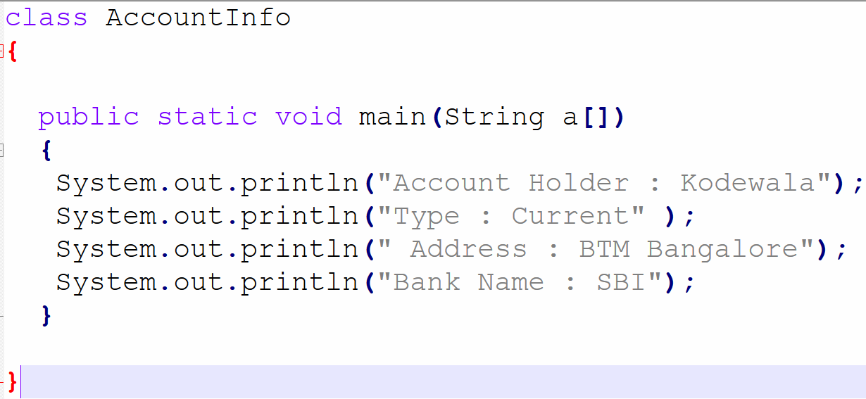
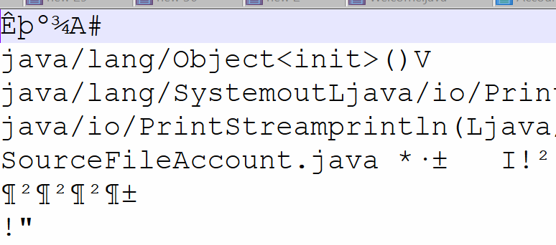

Compile javac Account.java

Byte Code(.class file)
Java AccountInfo
JVM(Memory)
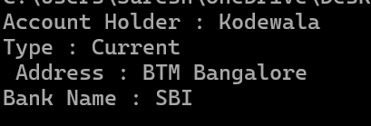

output

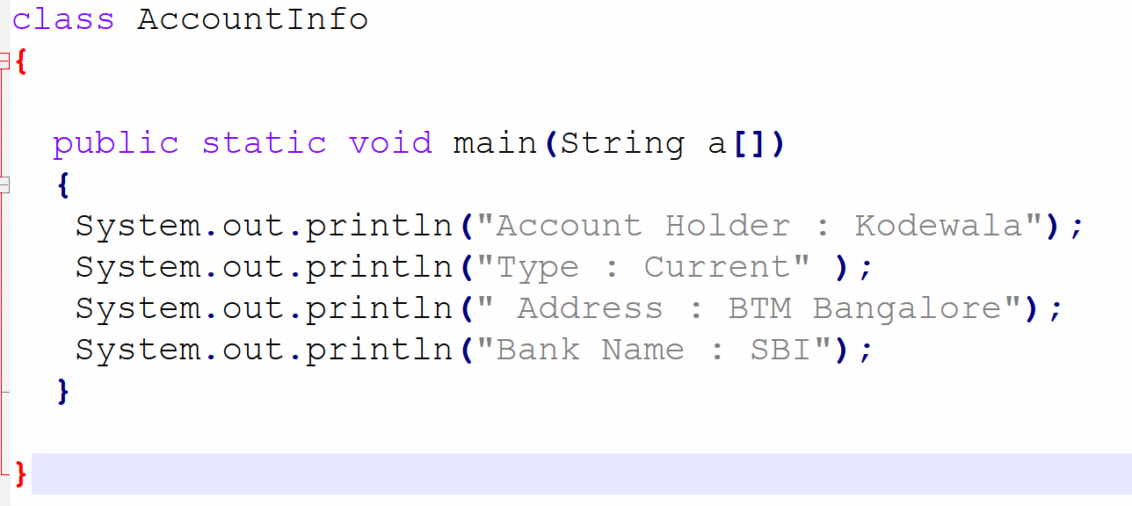

ThisIsMyClass class naming convention
PaymentDetails , PaymentInfo, Delivery , Account, Pickup
Method and Variable
camelCase
main
createAccount()
amount
maxNumber
doPayment

call main()
Main()


AccountInfo.main()
Static and non static Belongs to Objects

Belongs to class

